Cleaning data
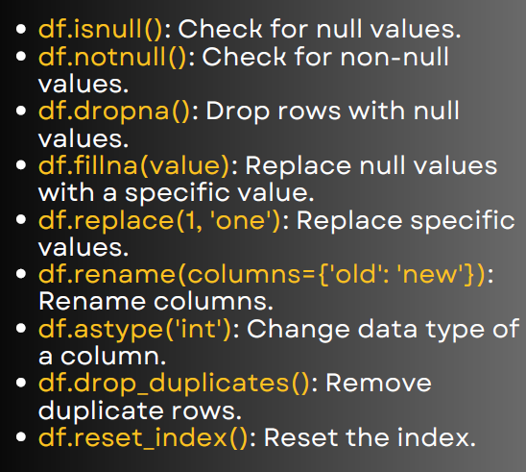

Data Cleaning in Pandas
import pandas as pd
import numpy as np
# Sample DataFrame
data = {
'Name': ['Amit', 'Sita', 'Ravi', 'Amit', np.nan],
'Age': [25, np.nan, 22, 25, 30],
'Salary': [50000, 60000, np.nan, 50000, 70000]
}
df = pd.DataFrame(data)
print(df)

1. Check for null values
print(df.isnull())
Returns a boolean DataFrame indicating NaN positions.

2. Check for non-null values
print(df.notnull())
Opposite of isnull().

3. Drop rows with null values
print(df.dropna())
Drops any row with at least one NaN.

4. Fill null values with a specific value
print(df.fillna(0))
Replaces all NaN values with 0.

5. Replace specific values
print(df.replace(25, 26))
Replaces all occurrences of 25 with 26.

6. Rename columns
df_renamed = df.rename(columns={'Salary': 'Income'})
print(df_renamed)
Renames column Salary → Income.

7. Change data type of a column
df['Age'] = df['Age'].astype('int', errors='ignore')
print(df.dtypes)
Converts column to int (if possible).

8. Remove duplicate rows
print(df.drop_duplicates())
Removes duplicate rows.

9. Reset index
df_reset = df.reset_index(drop=True)
print(df_reset)
Resets index to default numbers (0,1,2…)

